DATA ANALYSIS OF NETFLIX'S CONTENT AND TRENDS

REPORT IS SUBMITTED IN PARTIAL FULFILLMENT OF THE REQUIREMENT OF THE DIPLOMA
IN
COMPUTER ENGINEERING
UNDER THE SUPERVISION OF
Ms. JAISHREE
BY
RAJ GURU (Roll No. 2236051022)
MAY - JUNE 2025


ADITYA INSTITUTE OF TECHNOLOGY
(Unit of Dr. R.N. Gupta Technical Educational Society)
AFFILIATED TO BOARD OF TECHNICAL EDUCATION, DELHI - 110088
DECLARATION
This is to certify that this project report entitled “Data Analysis of Netflix's Content and Trends” which is submitted by me in partial fulfillment of the requirement for the award of Diploma in Computer Engineering to Aditya Institute of Technology, Delhi comprises only my original work and due acknowledgement has been made in text to all material used.
Date: 16/04/2025
Student’s Name: RAJ GURU
Roll No. 2236051022

SUBMITTED TO:
Ms. JAISHREE
Lecturer (Computer Engineering)

CERTIFICATE
This is to certify that this project report entitled “Data Analysis of Netflix's Content and Trends” which is submitted by Raj Guru (Roll No. 2236051022) in partial fulfillment of the requirement for the award of Diploma in Computer Engineering to Aditya Institute of Technology, Delhi is a record of student’s own work carried out by him under my supervision. The matter embodied in this report is original and has not been submitted for the award of any other degree.
Date: 16/04/2025
(Signature)
Mrs. JAISHREE
ACKNOWLEDGEMENT
I express my heartiest gratitude and respectful regards to Ms. Jaishree, my project guide, for her valuable guidance, constructive criticism and consistent enthusiastic interest during the course of investigation and writing of manuscript that led this work to its successful completion. I regard my sincere thanks to the technical staff at the organization that helped me during the project and made this project successful.
I would also like to express my profound sense of gratitude to our internal guide Ms. Jaishree, Lecturer of the Department of Computer Engineering, Aditya Institute of Technology, for her support and encouragement while doing the project. Last but not the least, I am thankful to my parents and friends for their constant support and motivation throughout this journey.
I am highly indebted to the Department of Computer Engineering, Aditya Institute of Technology for their continuous support regarding our project report.

INDEX
CHAPTER 1 INTRODUCTION
1.1 Introduction
1.2 Project Objective
1.3 Project Design Issues
1.4 Power Consumption (Optional)
1.5 Reliability (Optional)
CHAPTER 2 OVERVIEW OF PROJECT
2.1 Dataset Description
2.2 Tools & Technologies Used
2.3 Data Overview
2.4 Data Cleaning & Transformation
2.5 Project Layout & Structure
CHAPTER 3 WORKING OF PROJECT
3.1 Step-by-Step Working
3.2 Analysis Modules & Logic
3.3 Limitations
3.4 Advantages
3.5 Disadvantages
CHAPTER 4 APPLICATIONS & SCOPE
4.1 Real-World Applications
4.2 Scope for Future Work
CHAPTER 5 HARDWARE & SOFTWARE USED
5.1 Software Stack
5.2 Tools & Libraries Used
CHAPTER 6 RESULTS AND DISCUSSION
6.1 Data Analysis Results (Charts, Tables, Findings)
6.2 Conclusion
CHAPTER 7 REFERENCES

CHAPTER 1 - INTRODUCTION

1.1 Introduction
This project titled “Data Analysis of Netflix’s Content and Trends” focuses on analyzing the vast content library of Netflix using data science techniques. The Netflix platform has become a global hub for entertainment, offering a wide range of TV shows, movies, documentaries, and stand-up comedy shows. This project aims to gain insights into various aspects such as genre distribution, country-wise content, content ratings, release year trends, and more using Python libraries and data visualization tools.

1.2 Project Objective
The main goal of this project is to understand Netflix’s content using data. We want to find answers to questions like:
- How many movies and TV shows are there?
- Which genres (like drama or comedy) are most popular?
- Which countries make the most content?
- What are the different types of content ratings?
- How has Netflix’s content grown over the years?

1.3 Project Design Issues
While working on this project, we faced a few problems like:
- Understanding the distribution of movies and TV shows.
- Identifying the most common genres and popular content.
- Analyzing country-wise contributions to Netflix’s content.
- Understanding content rating distribution and duration trends.
- Creating clear and easy-to-understand charts was important.

1.4 Power Consumption
This project is software-based and does not involve hardware components. Therefore, power consumption is negligible and only depends on the computing system used.

1.5 Reliability
The project uses a publicly available Netflix dataset which is consistent and reliable for performing content-based analysis. The findings and visualizations generated are repeatable and reproducible using the same dataset and methodology.

CHAPTER 2 - OVERVIEW OF PROJECT

2.1 Dataset Description
This project uses a dataset called ‘netflix_titles.csv’. It contains details about movies and TV shows available on Netflix. Some of the main details in the dataset are:
- Title: Name of the show or movie
- Type: Movie or TV Show
- Director and Cast: People who made and acted in it
- Country: Where it was made
- Release Year: Year it was released
- Rating: Age group recommendation like PG, R, etc.
- Duration: Length of movie or number of seasons
- Genre: Type of content like Drama, Comedy, etc.

2.2 Tools and Technologies Used
We used the following tools and software to complete the project:
- Python: For data analysis and cleaning
- Jupyter Notebook: To write and run Python code
- Pandas: To work with data in table format
- NumPy: For basic math operations
- Plotly Express: For creating charts and graphs

2.3 Data Overview
The dataset was loaded and the first step was to check how the data looks. We used simple commands to see the first few rows of the table and understand the structure of the data. This helped us plan what to analyze.

2.4 Data Cleaning and Transformation
Before analyzing, we cleaned the data:
- Removed rows with missing values.
- Dropped columns we did not need.
- Changed the date format to proper year format.
- Renamed columns for better understanding.
- Removed duplicate rows.
- Selected only the first genre if multiple genres were listed.

2.5 Project Layout and Structure
The project was divided into the following steps:
1. Importing libraries
2. Loading the dataset
3. Cleaning the data
4. Analyzing the data using charts
5. Finding insights and writing the conclusion
All these steps were written and run inside a Jupyter Notebook. Each section has code and its output clearly shown in the notebook.

CHAPTER 3 - WORKING OF PROJECT

3.1 Step-by-Step Working
Here is a simple explanation of how the project works step by step:
1. Import Python libraries like Pandas, NumPy, and Plotly.
2. Load the Netflix dataset using Pandas.
3. Clean the data by removing empty rows and fixing date formats.
4. Rename some columns and remove extra columns.
5. Analyze the data using graphs and charts.
Each step was written in code in a Jupyter Notebook and the results were shown in the form of charts and tables.

3.2 Analysis Modules and Logic
We performed different types of analysis on the dataset. Here are some of them:
- Count of Movies vs TV Shows using a pie chart.
- Top 5 directors with most titles using a bar chart.
- Most common genres like Drama and Comedy.
- Countries that have the most content like USA and India.
- Rating distribution like TV-MA, PG, etc.
- Average duration of movies by genre.
- Number of titles released each year.
- Top genres in Indian content.
- Most common release years in USA content.

3.3 Limitations
Some limitations of this project are:
- The dataset may not be updated with latest titles.
- Some data may be missing or incomplete.
- The analysis is based only on available data, not user preferences or views.

3.4 Advantages
Some advantages of this project are:
- Helps understand Netflix content better.
- Easy to use tools and libraries.
- Visual charts make the data easy to understand.
- Can be extended with more datasets in future.

3.5 Disadvantages
Some disadvantages are:
- Cannot suggest content to users.
- Cannot measure popularity or watch time.
- Limited only to content data, not user behavior.

CHAPTER 4 - APPLICATIONS & SCOPE OF THE PROJECT

4.1 Real-World Applications
This project can be used in many real-world situations. Some examples are:
- Media Companies can understand what type of content people like.
- Streaming Platforms can use such analysis to improve their content library.
- Data Analysts can study content trends to make business decisions.
- Students and beginners can learn data analysis using this project as a reference.

4.2 Scope for Future Work
There is a lot of scope to improve and expand this project in the future:
- Add user ratings and reviews for better analysis.
- Compare Netflix content with other streaming platforms like Amazon Prime or Disney+.
- Build a recommendation system using content data.
- Study how content trends change with time and regions.

CHAPTER 5 - HARDWARE & SOFTWARE USED

5.1 Software Stack
This project was fully developed using software tools. The main software used includes:
- Python: Main programming language used for data analysis.
- Jupyter Notebook: Used to write and run Python code in an easy way.
- Windows/Linux Operating System: Used to run the project.

5.2 Tools and Libraries Used
The following Python libraries were used in this project:
- Pandas: To read and work with data in table format.
- NumPy: For mathematical operations and calculations.
- Plotly Express: To create interactive graphs and charts.
- Matplotlib (optional): Can be used for basic graphs.
These tools helped in cleaning the data, analyzing it, and creating visualizations for better understanding.

CHAPTER 6 - RESULT AND DISCUSSION

6.1 Result
After analyzing the Netflix dataset, we found many interesting results:
- Netflix has more movies than TV shows.
- The most common genres are Drama and Comedy.
- Most content on Netflix is from the United States and India.
- The most common content ratings are TV-MA, TV-14, and PG-13.
- Movie durations vary by genre. For example, Comedy and Drama movies are longer, while Stand-Up Comedy is shorter.
- The number of titles added increased a lot after 2015.
- The most active release years were 2016 to 2020.

6.2 Conclusion
This project helped us understand Netflix’s content in a better way. We learned how to use Python tools to clean and study data. By creating graphs and analyzing the dataset, we got useful insights about content trends on Netflix.
This kind of project is helpful for media companies, data analysts, and students. It also shows how powerful data analysis can be in understanding large amounts of information.
In future, we can add more features like user ratings or compare with other platforms to make the project even better.

6. Results and Discussion

Figure 1: Movie vs TV Show Distribution
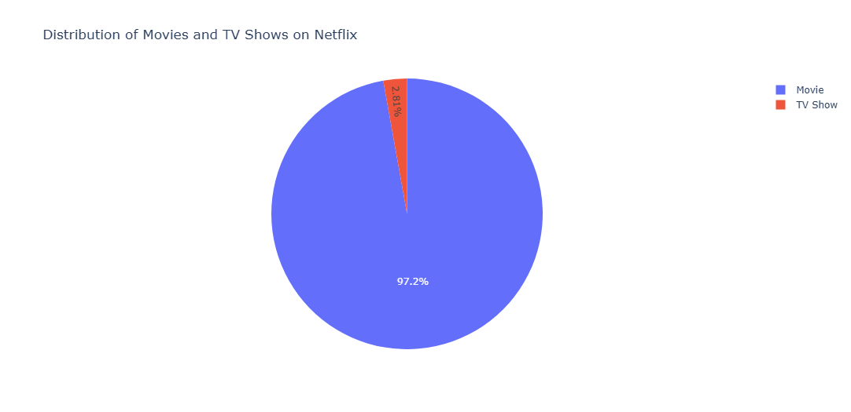
Netflix's content library primarily comprises movies, which account for 97.2% of the available titles. This translates to a total of 4,673 movies, significantly overshadowing the presence of TV shows. In comparison, TV shows make up only 2.8% of the collection, with a modest count of 135 titles.
This bar chart shows the number of titles released each year. We observe a significant rise in the number of titles after 2010, with a peak around 2018. This indicates Netflix's growing content library over time.

Figure 2: Top 5 Most Titles Directors
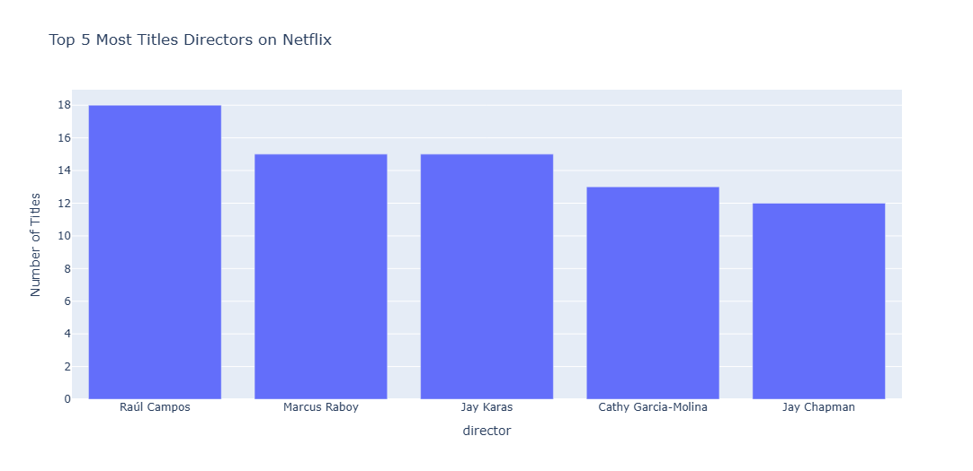
Top 5 Directors with the Most Titles on Netflix
Upon analyzing the Netflix dataset, the top five directors with the highest number of titles are as follows:
- Raúl Campos: 18 titles
- Marcus Raboy: 15 titles
- Jay Karas: 15 titles
- Cathy Garcia-Molina: 13 titles
- Jay Chapman: 12 titles
These directors have made significant contributions to Netflix's content library, showcasing their prolific work and impact on the entertainment industry.

Figure 3: Top 7 Most Common Genres
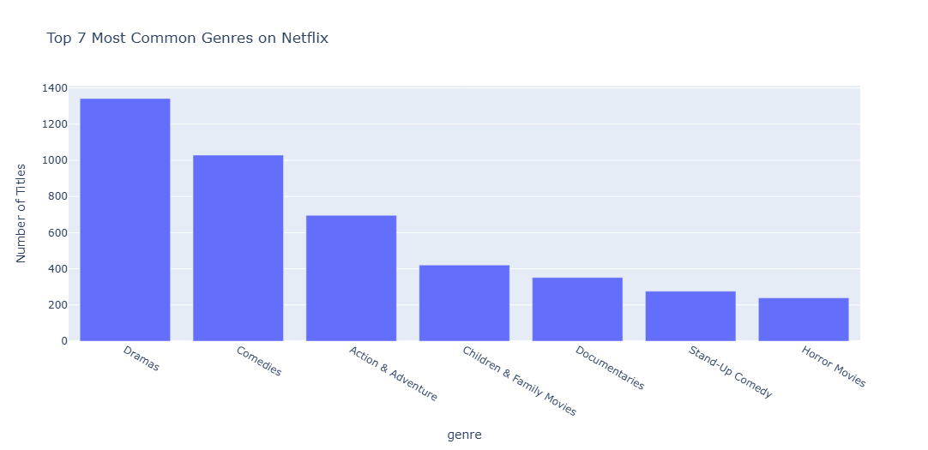
Top 7 Most Common Genres on Netflix
Based on an analysis of the Netflix dataset, the top seven most common genres are as follows:
- Dramas: 1,342 titles
- Comedies: 1,029 titles
- Action & Adventure: 696 titles
- Children & Family Movies: 421 titles
- Documentaries: 352 titles
- Stand-Up Comedy: 276 titles
- Horror Movies: 239 titles

Figure 4: Top Countries with the Most Content
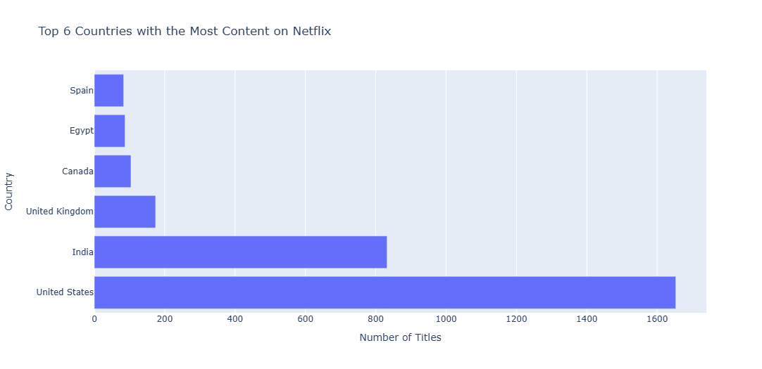
Top Countries with the Most Content on Netflix
The analysis of the Netflix dataset reveals the top countries contributing the most content to its library:
- United States: 1,653 titles
- India: 832 titles
- United Kingdom: 174 titles
- Canada: 104 titles
- Egypt: 87 titles
- Spain: 83 titles
These countries play a pivotal role in shaping Netflix's diverse content library, catering to a global audience with varied tastes and preferences.

Figure 5: Top 6 Content Ratings
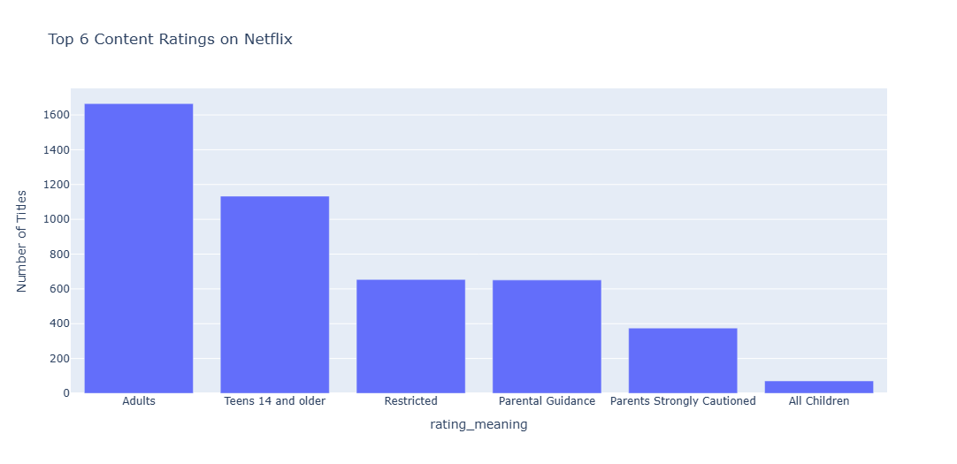
Top 6 Content Ratings on Netflix
The analysis of the Netflix dataset reveals the six most common content ratings, their meanings, and the respective number of titles:
- Adults (TV-MA): 1,665 titles
  - Suitable for mature audiences; not recommended for children.
- Teens 14 and older (TV-14): 1,133 titles
  - Appropriate for teenagers and older viewers.
- Restricted (R): 654 titles
  - Content typically requiring viewers to be 17+ or accompanied by an adult.
- Parental Guidance (TV-PG): 651 titles
  - Content where parental guidance is suggested for younger audiences.
- Parents Strongly Cautioned (PG-13): 375 titles
  - Indicates some material may be inappropriate for children under 13.
- All Children (TV-Y): 71 titles
  - Specifically designed to be suitable for young viewers.
These content ratings emphasize Netflix's commitment to providing diverse and age-appropriate choices, helping both viewers and parents make informed decisions.

Figure 6: Average Duration of Movies by Genre
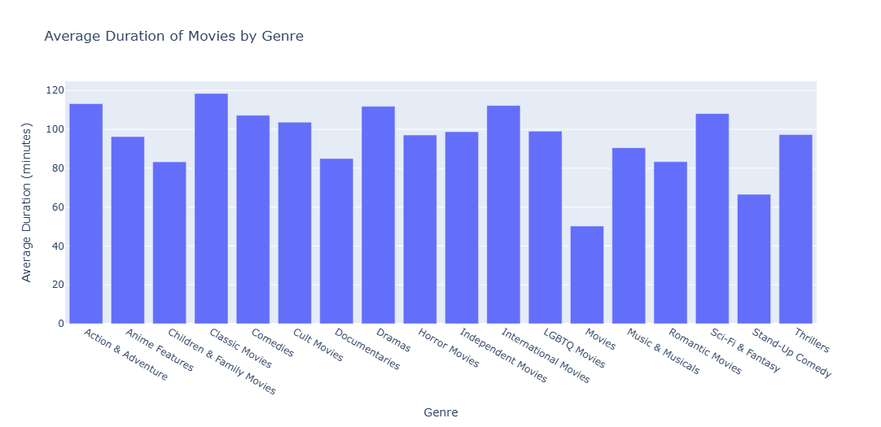
Average Duration of Movies by Genre
The table below provides the average duration (in minutes) of movies for each genre:
Genre | Average Duration (minutes)
Action & Adventure | 113.16
Anime Features | 96.22
Children & Family Movies | 83.24
Classic Movies | 118.43
Comedies | 107.18
Cult Movies | 103.64
Documentaries | 84.97
Dramas | 111.79
Horror Movies | 97.03
Independent Movies | 98.70
International Movies | 112.24
LGBTQ Movies | 99.00
Movies | 50.23
Music & Musicals | 90.50
Romantic Movies | 83.33
Sci-Fi & Fantasy | 108.09
Stand-Up Comedy | 66.56
Thrillers | 97.24
Analysis
Longer Movies:
- Classic Movies have the longest average duration, at approximately 118 minutes.
- Action & Adventure movies follow closely, averaging around 113 minutes.
Shorter Movies:
- Children & Family Movies and Romantic Movies are among the shortest, each averaging roughly 83 minutes.
- Stand-Up Comedy has a notably short average duration of 67 minutes.
Notable Anomaly:
- The category labeled "Movies" has an unusually short average duration of only 50 minutes, which could indicate a data issue or a mixed grouping requiring further investigation.
This analysis highlights how movie durations vary across genres, offering insights into the content's pacing and style.

Figure 7: Content Trends Over the Years on Netflix
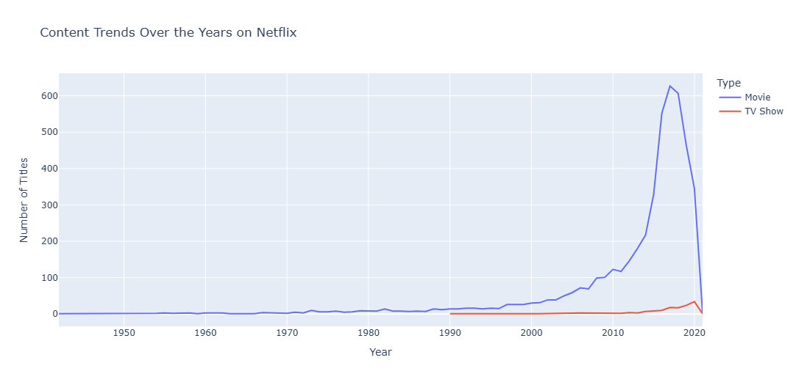
Content Trends Over the Years on Netflix
An analysis of the Netflix dataset reveals distinct trends in the number of titles added each year for movies and TV shows:
Movies
- The number of movies added to Netflix has grown significantly, particularly after 2010.
- A peak in the addition of titles was observed during 2018-2019, followed by a noticeable decline in subsequent years.
TV Shows
- The number of TV shows has shown a gradual increase over time.
- However, the growth rate for TV shows has been much slower compared to that of movies.

Figure 8: Number of Titles Released in India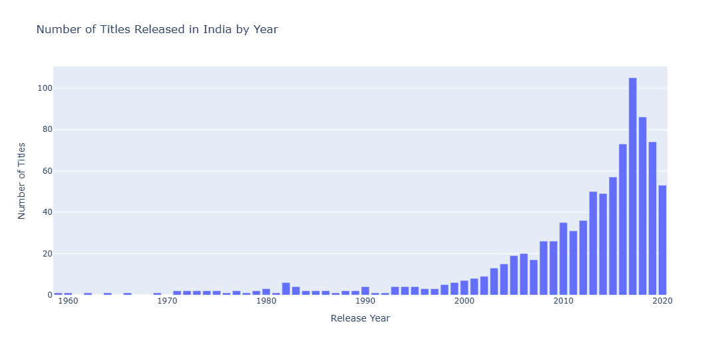
2017: 105 titles
Brief Explanation: The year 2017 marked the peak of India's content releases on Netflix, showcasing a significant focus on expanding the platform's offerings in the region.

Figure 9: Top 3 Genres in Content from India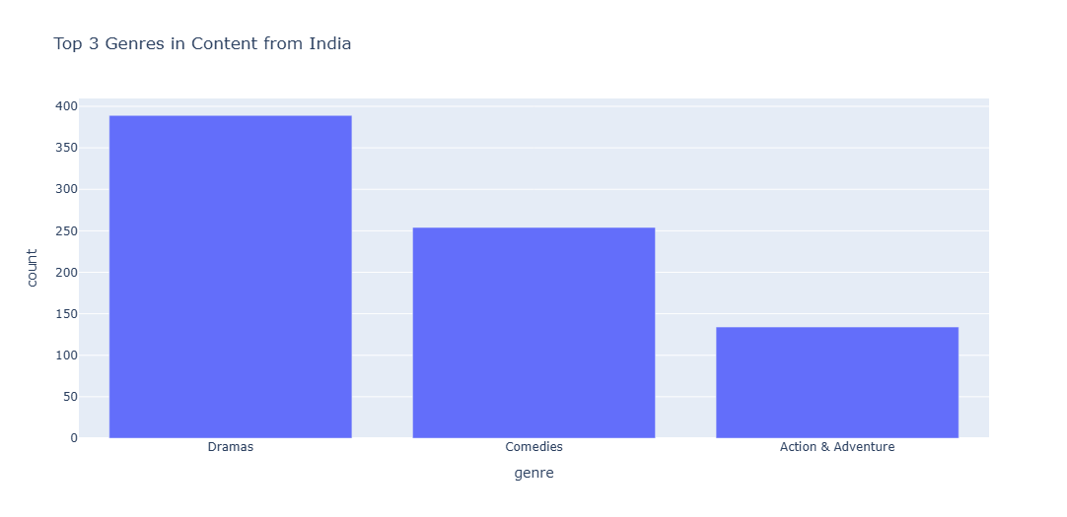
Top 3 Genres in Content from India
Genre | Count
Dramas | 389
Comedies | 254
Action & Adventure | 134
Brief Explanation: The table above shows the top 3 genres in Netflix's Indian content based on the number of titles available.
Dramas lead with 389 titles, showing that dramatic storytelling is very popular in the Indian segment.
Comedies come in second with 254 titles, indicating a strong interest in humorous content.
Action & Adventure completes the list with 134 titles, showcasing the demand for high-energy, thrilling content.

Figure 10: Titles Released by Year in the United States
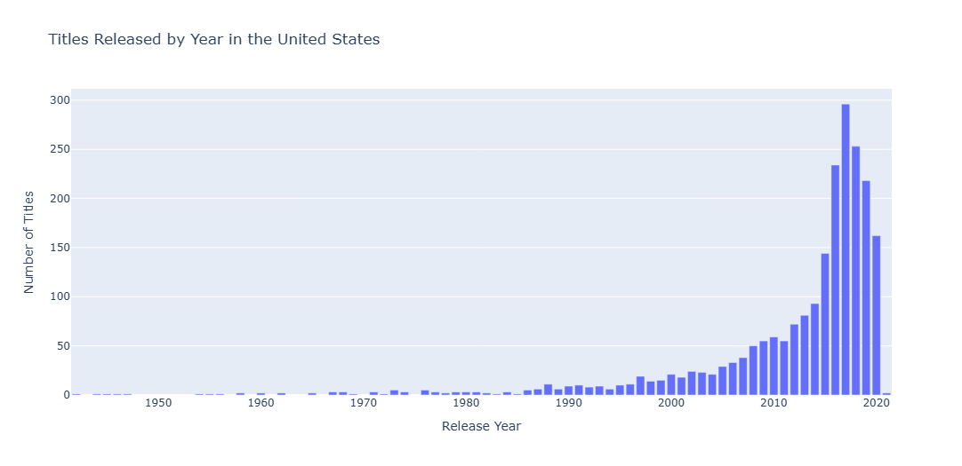
art shows the trend of content release the United States over the years. A sharp rise is observed after 2005, peaking around 2018–2019, indicating the streaming boom in the US.

d by movies, with 4,673 titles (97.2%) of the content. TV shows make up only 135 titles (2.8%) of the collection.

* Which 5 directors have the most titles on Netflix?
Clean the Data: Ensure that we clean any white spaces after the comma in the director names.

Use pandas to count the number of titles directed by each director.

Top 5 Directors with the Most Titles on Netflix

* What are the most common genres for movies and TV shows on Netflix?

* Which countries have the most content on Netflix?

* What is the distribution of different content ratings (like PG, PG- 13, R, etc.) on Netflix?

Top 6 Content Ratings on Netflix

* What is the average duration of movies? How does it vary by genre?

* How has the number of movies and TV shows added each year changed over time?

Content Trends Over the Years on Netflix

* "In which year did India release the highest number of titles on Netflix?"

* What are the top 3 most common genres in content from India?

Top 3 Genres in Content from India

Brief Explanation:

* Which year had the highest number of titles released in the United States on Netflix?

Distribution of Titles by Release Year in the United States

Data Analysis of Netflix's Content and Trends

Introduction

Dataset Overview

Data Cleaning and Preparation

Main Findings

Visual Charts Used

o Conclusion

CHAPTER 7 - REFERENCES
1. Netflix Dataset: https://www.kaggle.com/datasets/shivamb/netflix-shows
2. Python Programming Language - https://www.python.org/
3. Pandas Library - https://pandas.pydata.org/
4. NumPy Library - https://numpy.org/
5. Plotly Express - https://plotly.com/python/plotly-express/
6. Jupyter Notebook - https://jupyter.org/

